Chapter 2, Solution 41

Let R₀ = combination of three 12Ω resistors in parallel

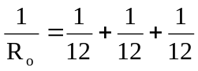 R_{o} = 4

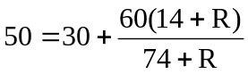 74 + R = 42 + 3R

or R = 16 Ω

